

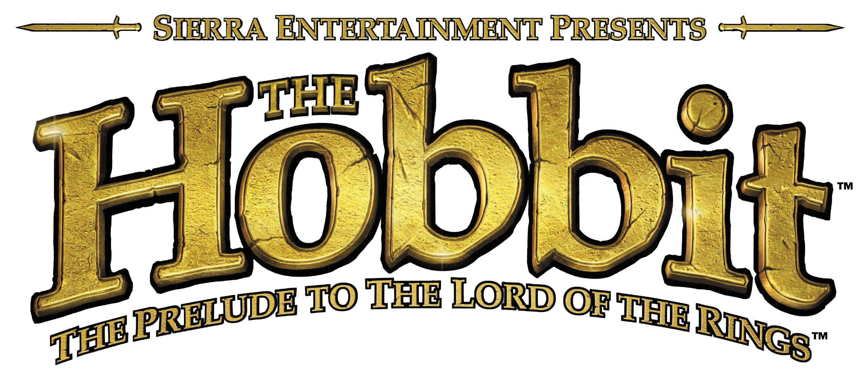

Fact Sheet

Publisher | Sierra Entertainment, Inc.
Developer | Inevitable Entertainment
Format | PlayStation®2 Computer Entertainment System
Product Overview | “The Hobbit” is a third-person action/adventure game set in the world of Middle-earth. In the game, you take the persona of Bilbo Baggins, an unassuming Hobbit who has been unwittingly thrust into an epic adventure.  Explore the mystical world of Middle-earth where you’ll need to jump gaping chasms, climb treacherous mountains, solve mind bending puzzles and battle hordes of enemies just to survive. Meet enchanting Elves, battle-ready Dwarves, a powerful Wizard, massive Trolls, bloodthirsty goblins, and more as you traverse from the peaceful lands of the Shire to the harrowing forests of Mirkwood. And that’s just the beginning.  J.R.R. Tolkien’s The Hobbit and The Lord of the Rings have set the standard for fantasy writers and creators of epic worlds. The novels are massive best sellers, having sold close to 100 million copies worldwide and been translated into 26 different languages. The Lord of the Rings trilogy is the subject of three movies being created by New Line Cinema, the second of which, The Two Towers, was released on December 18, 2002 and is one of the hottest movies of 2002/2003.
Product  Features | - Based upon J.R.R. Tolkien’s The Hobbit, the prelude to The Lord of the Rings  - Jump, ledge grab, shimmy, climb ropes and ladders, and journey through the legendary world of Middle-earth with expansive 3-D action-packed environments.  - Play in such recognizable areas as Mirkwood, Laketown, and the Lonely Mountain.  - Meet legendary characters like Gandalf, Thorin, and Gollum along your journey.  - Confront the dragon Smaug in the depths of Lonely Mountain and take on teams of enemies in the epic Battle of the Five Armies.  - Behold the deep combat systems combined with the best elements of action, stealth, role-playing and puzzle solving.  - Battle hordes of orcs, goblins, wargs and more in your epic quest to retake Lonely Mountain.
Pricing and Availability | “The Hobbit” is scheduled for release in September 2003. The suggested retail price is $49.99.
ESRB Rating | (E) Everyone

########

For more information, press only:
Adam Kahn, Sierra Entertainment, Inc., (425) 638-5606, adam.kahn@sierra.com

The Hobbit and the characters, events, items and places therein are trademarks of The Saul Zaentz Company dba Tolkien Enterprises and are used, under license, by Sierra Entertainment, Inc.

